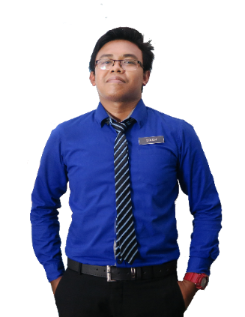

**(Jan 2018 - Jan 2018)**

**(Jan 2018 - Jan 2018)**

**(2012 - 2013)**

**(2012 - 2013)**

**(2012 - 2013)**

AZIMI

WAN

ALIF

**DARIK BIN PASSAN**

**REFERENCE**

Supervisor

F62, Kinta City Shopping Centre,

No 2, Jalan The Lean Swee,

Off Jalan Sultan Azlan Shah Utara,

31400 Ipoh, Perak.

Phone: +6016-6230252

**ACHIEVEMENT / PARTICIPATION**

* Pertandingan Futsal 2015
* Sepak Takraw Wakil Sekolah 2014
* Kawad Kaki Kadet Remaja Sekolah 2014
* Pertandingan Baling Baling 2015

**(2018 - Present)**

**EXPERIENCE**

**SMK BANDAR BARU SUNGAI BULOH**

Chemistry Teacher

**SMK BANDAR BARU SUNGAI BULOH**

Chemistry Teacher

**CHATIME**

Barista (Part Time)

Sijil Pelajaran Malaysia (SPM)

**KOLEJ MATRIKULASI KEDAH (KMK)**

Bachelor of Education in Science

**UNIVERSITI TEKNOLOGI MARA (UiTM)**

Master in Chemistry

**SEKOLAH MENENGAH KEBANGSAAN FELDA JELAI**

Science Stream

**(2016 - 2018)**

**UNIVERSITI TEKNOLOGI MARA (UiTM)**

**EDUCATION**

Dedicated and self-motivated individual seeking for a challenging working opportunity in an organization to utilize my personal capability and creativity that would allow me to develop my skills while contributing to the organizational goals.

**WAN ALIF AZIMI BIN WAN MAZDI**

**NO. 29 LINTASAN ROKAM 8, PEKAN RAZAKI, 31350 IPOH, PERAK**

**CAREER OBJECTIVE**

**MALAYSIAN**

**SINGLE / MALE / MALAY**

**25 SEPTEMBER 1997**

**PROFESSIONAL SKILLS**

**MICROSOFT WORD**

**MICROSOFT EXCEL**

**COMPUTER**

**MICROSOFT POWERPOINT**

**ENGLISH**

**MALAY**

**LANGUAGES**

**PERSONAL DETAILS**

**PERSONAL SKILLS**

**wanbelum7@yahoo.com**

**+6017-8472800**

**CONTACT**

**MANAGEMENT**

**COMMUNICATION**

**TEAMWORK**

**MULTITASK**